**Subscribers Galore : Exploring World’s Top Youtube Channels**

**1 INTRODUCTION**

**1.1 Overview**

A subscriber to a channel on the video-sharing YouTube is a user who has chosen to receive the channel's content by clicking on that channel's "Subscribe" button, and each user's subscription feed consists of videos published by channels to which the user is subscribed. The ability to subscribe to users was introduced in October 2005. YouTube began publishing a list of its most-subscribed channels in April 2006. An early archive of the list dates to May 2006. The following table lists the 50 most-subscribed YouTube channels, as well as the primary language and content category of each channel. The channels are ordered by number of subscribers; those whose displayed subscriber counts are identical are listed so that the channel whose current growth rate indicates that its displayed subscriber count will exceed that of the other channel is listed first. Automatically generated channels that lack their own videos (such as Music and News) and channels that have been made effectively obsolete as a result of the transferal of their content (such as Justin Bieber VEVO and Taylor Swift VEVO) are excluded. As of February 2023, 21 of the 50 channels listed primarily produce content in English while 16 primarily produce content in Hindi. All 50 of the channels have surpassed 40 million subscribers, 39 of them have surpassed 50 million subscribers, 23 of them have surpassed 60 million subscribers, 16 of them have surpassed 70 million subscribers, 12 of them have surpassed 80 million subscribers, 10 of them have surpassed 90 million and 7 of them have surpassed 100 million subscribers. Only 1 channel (T-Series) has surpassed 200 million subscribers.

1.2 Purpose

The main purpose of YouTube is to provide a platform for users to watch, share, and create videos. In the last decade, YouTube has just become the most popular video-sharing platform in the world.

2.Problem definition & Design Thinking

2.1 Empathy Map

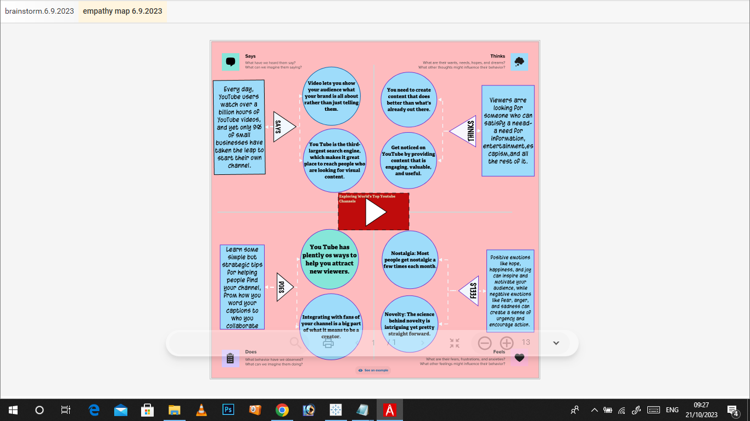

2.2 Ideation & Brainstorming

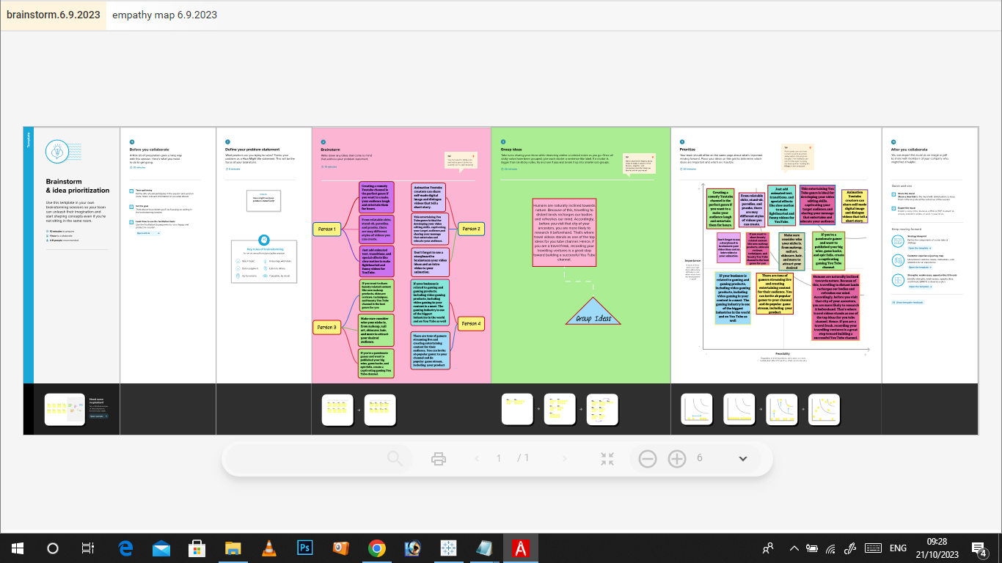

3.Result

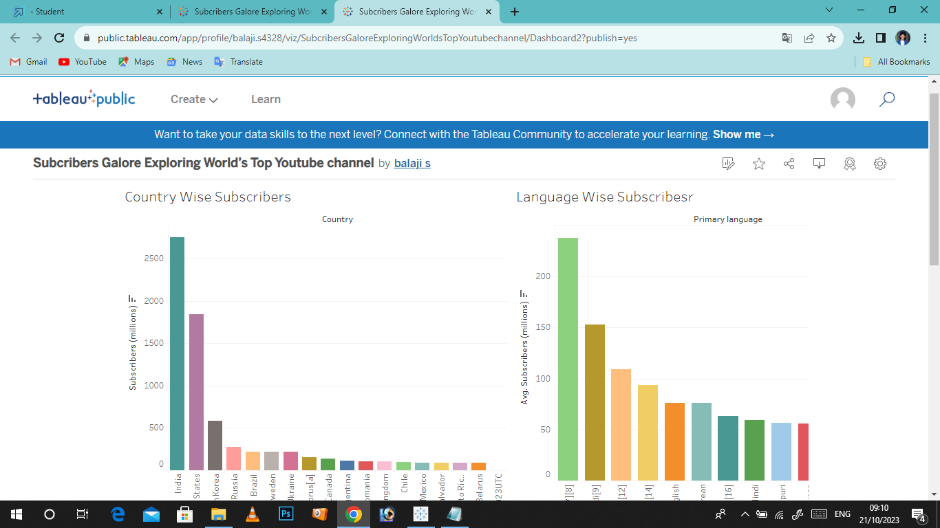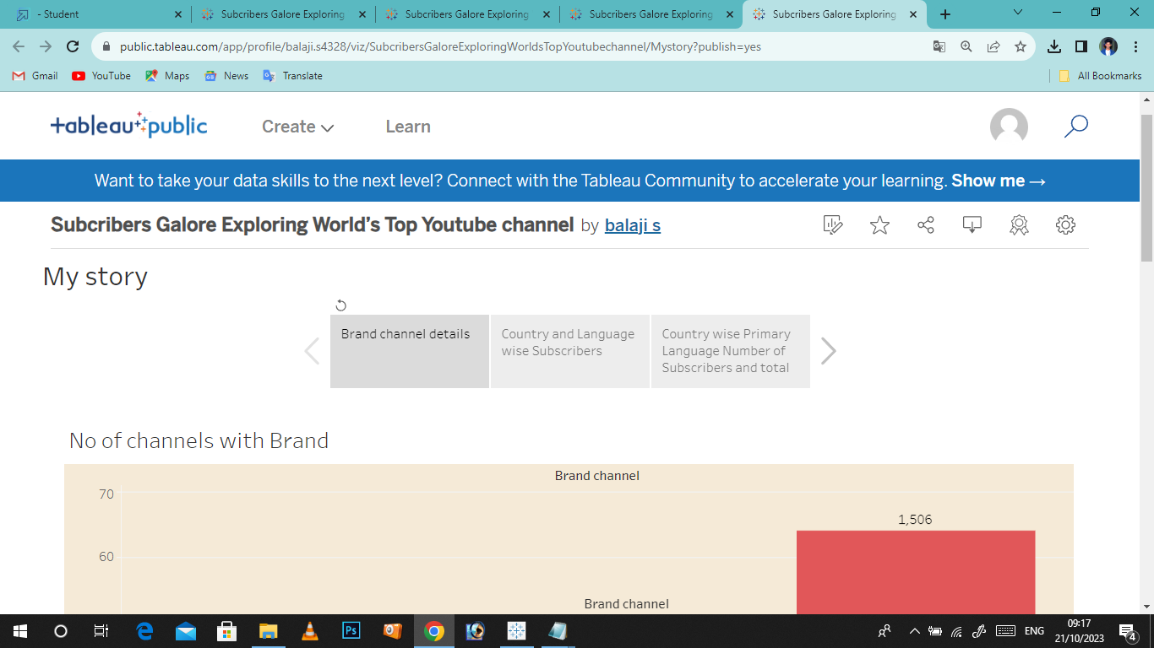

4.Advantages & Disadvantages

Advantages

Active Subscribers pave a way for your viewers to be alerted when you upload a video. YouTube ranks videos on a metric called dwell time i.e the hours of video consumed by viewers. The higher the dwell time when a video is fresh, the more likely YouTube is to share it with similar users.

Disadvantages

Our recommendation is to avoid buying YouTube subscribers. While it might provide a short-term impression of success by inflating your subscriber count, it won't result in real views or engagements. Such attempts can also be easily detected by YouTube and can result in your account getting banned or deleted.

5. Application

There is no direct way to earn money by subscribing to a YouTube channel. YouTube does not pay users for subscribing to channels. However, if you are a content creator and you have your own YouTube channel, you can earn money through the YouTube Partner Program by monetizing your videos and earning advertising revenue.

6. Conclusion

Subscribers are also important because YouTube will send them notifications about your new videos and feature them on their homepage, helping generate more views. Subscribers also watch twice as much video as non-subscribers, so the more subscribers you have, the more watch time your videos will collect.

7. Future Scope

Yes there is and it's a growing market. Shame on anyone who tries to tell you that you “shouldn't make a YouTube channel for the money”. Don't let people tell you what to do with your life. If starting a channel with every intention to make it a career and to earn a decent living off it then go for it.

Over the next decade, expect it to expand into an all-encompassing entertainment service, where you'll not just watch and listen: you'll play. Games, and interactive experiences. In both cases partly driven by YouTube's evolution into the world's largest catalogue of virtual reality content.